

**Green University of Bangladesh**

**Department of Computer Science and Engineering (CSE)**

**Faculty of Sciences and Engineering**

**Semester: (Spring, Year:2021), B.Sc. in CSE (Day/Eve)**

**Lab Project Name: Quiz system with EMU8086**

**Student Details**

|  |  |  |
| --- | --- | --- |
| **Name** | | **ID** |
| **1.** | Prattay Dhar Logna | 201002133 |

**Course Teacher’s Name : Md. Rajibul Palas**

**[For Teachers use only: Don’t Write Anything inside this box]**

|  |
| --- |
| **Lab Project Status**  **Marks: ………………………………… Signature: .....................**  **Comments: .............................................. Date: ..............................** |

Table of Contents

Chapter 1 Introduction 3

1.1 Introduction 3

1.2 Objective 3

Chapter 2 Implementation of the Project 4

2.1 Design Quiz System 4

2.2 Implementation 5

2.3 Source Code 8

Chapter 3 Performance Evaluation 15

3.1 Simulation Procedure 15

3.2 Results and Discussions 16

Chapter 4 Conclusion 17

4.1 Introduction 17

4.1 Practical Implications 17

4.2 Scope of Future Work 17

References 17

# Chapter 1 Introduction

## Introduction

Quiz system is a game concept. In this game, we have set 10 questions. For each right answer 1 mark will be increased and for each wrong answer 1 mark will be decreased from total points and at the end of the quiz total marks will be shown. We make it by the Assembly Language. Assembly language is the most basic programming language available for any processor. With assembly language, a programmer works only with operations implemented directly on the physical CPU. Assembly language lacks high-level conveniences such as variables and functions, and it is not portable between various families of processors. Nevertheless, assembly language is the most powerful computer programming language available, and it gives programmers the insight required to write effective code in high-level languages.

## Objective

We have set 10 questions. For each right answer 1 mark will be increased and for each wrong answer 1 mark will be decreased from total points and at the end of the quiz total marks will be shown.

• To build a quiz system which is easy to use for all and it’s easy to understand for all.

• Learn more about Microprocessors, registers & EMU8086

# Chapter 2

# Implementation of the Project

* 1. **Design Quiz System**

Quiz system is a game concept. In this game, we have set 10 questions. For each right answer 1 mark will be increased and for each wrong answer 1 mark will be decreed from total points and at the end of the quiz total marks will be shown.

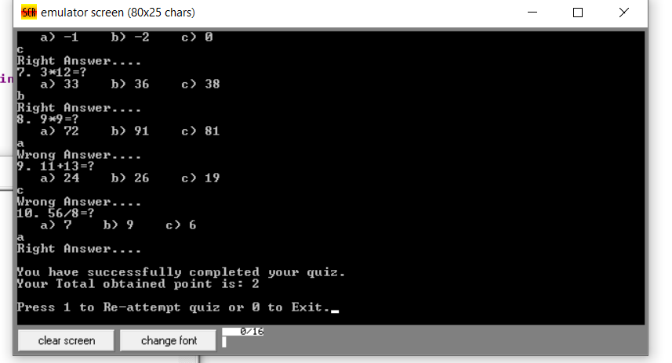

Figure 2.1: Full Output

## Implementation

## Now we will discuss about some important part of our project code.

## 

## 

## we have set 10 variables from msg 1 to msg9 for printing our desired strings and also we have used Q1-Q9 and QA1-QA9 for printing our desired questions and their options.

## 

## 

## 

## 

## Now we have taken a start level. At first we have printed a new line and then we have taken an input to compare carriage return. If it is eqal then it will go to the QSn1 level .

## 

## 

## Now we will go to the question 1 level and 1 input will be taken and it will be compared to the correct answer. If it is equal then it will go to the Qsn2 level otherwise it will reach to the Qsnw2 level.

## 

## 

## In QSN2 level bl will be incremented for right answer then again the same procedure for input will take place.

## 

## In QSnw2 level bl will be decremented for wrong answer then again the same procedure for input will take place.

## 

## 

## 

## 

## In exit level we have added 48 with bl to convert our inner ascii to decimal so that the user may easily understand the obtained marks.

## 2.3 Source Code

## .MODEL SMALL

## .STACK 100H

## .DATA

## MSG1 DB ' .....WELCOME TO YOUR FIRST QUIZ.....$'

## MSG2 DB 'Rules : $'

## MSG3 DB '*. For Every Correct answer you will get 1 point.$'

## MSG4 DB '*. For Every Wrong answer 1 Point will cut from your total point.$'

## MSG5 DB 'Press Enter to start the quiz : $'

## MSG6 DB 'Right Answer....$'

## MSG7 DB 'Wrong Answer....$'

## MSG8 DB 'You have successfully completed your quiz.$'

## MSG9 DB 'Your Total obtained point is : $'

## MSG10 DB 'Press 1 to Re-attempt quiz or 0 to Exit.$'

## MSG11 DB ' ***Thank you.! ***$'

## Q1 DB '1. 2+3=?$'

## QA1 DB ' a) 5 b) 6 c) 7$'

## Q2 DB '2. 5+6=?$'

## QA2 DB ' a) 10 b) 11 c) 12$'

## Q3 DB '3. 15-12=?$'

## QA3 DB ' a) 5 b) 1 c) 3$'

## Q4 DB '4. 3*6=?$'

## QA4 DB ' a) 10 b) 18 c) 12$'

## Q5 DB '5. 6/3=?$'

## QA5 DB ' a) 2 b) 1 c) 12$'

## Q6 DB '6. 8-8=?$'

## QA6 DB ' a) -1 b) -2 c) 0$'

## Q7 DB '7. 3*12=?$'

## QA7 DB ' a) 33 b) 36 c) 38$'

## Q8 DB '8. 9*9=?$'

## QA8 DB ' a) 72 b) 91 c) 81$'

## Q9 DB '9. 11+13=?$'

## QA9 DB ' a) 24 b) 26 c) 19$'

## Q10 DB '10. 56/8=?$'

## QA10 DB ' a) 7 b) 9 c) 6$'

## .CODE

## MAIN PROC

## 

## MOV AX,@DATA

## MOV DS,AX

## 

## LEA DX,MSG1

## MOV AH,9

## INT 21H

## 

## CALL NL

## 

## LEA DX,MSG2

## MOV AH,9

## INT 21H

## 

## CALL NL

## 

## LEA DX,MSG3

## MOV AH,9

## INT 21H

## 

## CALL NL

## 

## LEA DX,MSG4

## MOV AH,9

## INT 21H

## 

## START:

## MOV BL, 0

## CALL NL

## 

## LEA DX,MSG5

## MOV AH,9

## INT 21H

## MOV AH, 1

## INT 21H

## CMP AL, 0DH

## JE QSN1

## JNE START

## 

## QSN1:

## CALL NL

## 

## LEA DX,Q1

## MOV AH,9

## INT 21H

## 

## CALL NL

## 

## LEA DX,QA1

## MOV AH,9

## INT 21H

## 

## CALL NL

## 

## MOV AH, 1

## INT 21H

## CMP AL, 'a'

## JE QSN2

## JNE QSNW2

## 

## QSN2:

## CALL NL

## LEA DX,MSG6

## MOV AH,9

## INT 21H

## INC BL

## CALL NL

## CALL QN2

## CALL INPUT

## CMP AL, 'b'

## JE QSN3

## JNE QSNW3

## QSNW2:

## CALL NL

## LEA DX,MSG7

## MOV AH,9

## INT 21H

## 

## DEC BL

## CALL NL

## 

## CALL QN2

## CALL INPUT

## CMP AL, 'b'

## JE QSN3

## JNE QSNW3

## QSN3:

## CALL NL

## 

## LEA DX,MSG6

## MOV AH,9

## INT 21H

## 

## INC BL

## CALL NL

## 

## CALL QN3

## CALL INPUT

## 

## CMP AL, 'c'

## JE QSN4

## JNE QSNW4

## 

## QSNW3:

## CALL NL

## 

## LEA DX,MSG7

## MOV AH,9

## INT 21H

## 

## DEC BL

## CALL NL

## 

## CALL QN3

## CALL INPUT

## 

## CMP AL, 'c'

## JE QSN4

## JNE QSNW4

## 

## QSN4:

## CALL NL

## 

## LEA DX,MSG6

## MOV AH,9

## INT 21H

## 

## INC BL

## CALL NL

## 

## CALL QN4

## CALL INPUT

## 

## CMP AL, 'b'

## JE QSN5

## JNE QSNW5

## 

## QSNW4:

## CALL NL

## 

## LEA DX,MSG7

## MOV AH,9

## INT 21H

## 

## DEC BL

## CALL NL

## 

## CALL QN4

## CALL INPUT

## 

## CMP AL, 'b'

## JE QSN5

## JNE QSNW5

## 

## QSN5:

## CALL NL

## 

## LEA DX,MSG6

## MOV AH,9

## INT 21H

## 

## INC BL

## CALL NL

## 

## CALL QN5

## 

## CALL INPUT

## 

## CMP AL, 'a'

## JE QSN6

## JNE QSNW6

## 

## QSNW5:

## CALL NL

## 

## LEA DX,MSG7

## MOV AH,9

## INT 21H

## 

## DEC BL

## CALL NL

## 

## CALL QN5

## CALL INPUT

## 

## CMP AL, 'a'

## JE QSN6

## JNE QSNW6

## 

## QSN6:

## CALL NL

## 

## LEA DX,MSG6

## MOV AH,9

## INT 21H

## 

## INC BL

## CALL NL

## 

## CALL QN6

## 

## CALL INPUT

## 

## CMP AL, 'c'

## JE QSN7

## JNE QSNW7

## 

## QSNW6:

## CALL NL

## 

## LEA DX,MSG7

## MOV AH,9

## INT 21H

## 

## DEC BL

## CALL NL

## 

## CALL QN6

## CALL INPUT

## 

## CMP AL, 'c'

## JE QSN7

## JNE QSNW7

## 

## QSN7:

## CALL NL

## 

## LEA DX,MSG6

## MOV AH,9

## INT 21H

## 

## INC BL

## CALL NL

## 

## CALL QN7

## CALL INPUT

## 

## CMP AL, 'b'

## JE QSN8

## JNE QSNW8

## 

## QSNW7:

## CALL NL

## 

## LEA DX,MSG7

## MOV AH,9

## INT 21H

## 

## DEC BL

## CALL NL

## 

## CALL QN7

## CALL INPUT

## 

## CMP AL, 'b'

## JE QSN8

## JNE QSNW8

## 

## QSN8:

## CALL NL

## 

## LEA DX,MSG6

## MOV AH,9

## INT 21H

## 

## INC BL

## CALL NL

## 

## CALL QN8

## CALL INPUT

## 

## CMP AL, 'c'

## JE QSN9

## JNE QSNW9

## 

## QSNW8:

## CALL NL

## 

## LEA DX,MSG7

## MOV AH,9

## INT 21H

## 

## DEC BL

## CALL NL

## 

## CALL QN8

## CALL INPUT

## 

## CMP AL, 'c'

## JE QSN9

## JNE QSNW9

## 

## QSN9:

## CALL NL

## 

## LEA DX,MSG6

## MOV AH,9

## INT 21H

## 

## INC BL

## CALL NL

## 

## CALL QN9

## CALL INPUT

## 

## CMP AL, 'a'

## JE QSN10

## JNE QSNW10

## 

## QSNW9:

## CALL NL

## 

## LEA DX,MSG7

## MOV AH,9

## INT 21H

## 

## DEC BL

## CALL NL

## 

## CALL QN9

## CALL INPUT

## 

## CMP AL, 'a'

## JE QSN10

## JNE QSNW10

## 

## QSN10:

## CALL NL

## 

## LEA DX,MSG6

## MOV AH,9

## INT 21H

## 

## INC BL

## CALL NL

## 

## CALL QN10

## CALL INPUT

## 

## CMP AL, 'a'

## JE EXIT

## JNE EXITW

## 

## QSNW10:

## CALL NL

## 

## LEA DX,MSG7

## MOV AH,9

## INT 21H

## 

## DEC BL

## CALL NL

## 

## CALL QN10

## CALL INPUT

## 

## CMP AL, 'a'

## JE EXIT

## JNE EXITW

## 

## EXIT:

## CALL NL

## 

## LEA DX,MSG6

## MOV AH,9

## INT 21H

## 

## INC BL

## CALL NL

## CALL NL

## 

## LEA DX,MSG8

## MOV AH,9

## INT 21H

## 

## CALL NL

## 

## LEA DX,MSG9

## MOV AH,9

## INT 21H

## 

## ADD BL, 48

## 

## CMP BL,57

## JG TEN

## MOV AH, 2

## MOV DL, BL

## INT 21H

## JMP EXIT1

## 

## EXITW:

## CALL NL

## 

## LEA DX,MSG7

## MOV AH,9

## INT 21H

## 

## DEC BL

## CALL NL

## CALL NL

## 

## LEA DX,MSG8

## MOV AH,9

## INT 21H

## 

## CALL NL

## CALL NL

## 

## LEA DX,MSG9

## MOV AH,9

## INT 21H

## 

## ADD BL,48

## MOV AH,2

## MOV DL, BL

## INT 21H

## 

## JMP EXIT1

## 

## TEN:

## MOV AH,2

## MOV DL,"1"

## INT 21H

## MOV DL,"0"

## INT 21H

## JMP EXIT1

## 

## NL:

## MOV AH,2

## MOV DL, 0AH

## INT 21H

## MOV DL, 0DH

## INT 21H

## RET

## 

## QN2:

## LEA DX,Q2

## MOV AH,9

## INT 21H

## 

## CALL NL

## 

## LEA DX,QA2

## MOV AH,9

## INT 21H

## RET

## 

## QN3:

## LEA DX,Q3

## MOV AH,9

## INT 21H

## 

## CALL NL

## 

## LEA DX,QA3

## MOV AH,9

## INT 21H

## RET

## 

## QN4:

## LEA DX,Q4

## MOV AH,9

## INT 21H

## 

## CALL NL

## 

## LEA DX,QA4

## MOV AH,9

## INT 21H

## RET

## 

## QN5:

## LEA DX,Q5

## MOV AH,9

## INT 21H

## 

## CALL NL

## 

## LEA DX,QA5

## MOV AH,9

## INT 21H

## RET

## 

## QN6:

## LEA DX,Q6

## MOV AH,9

## INT 21H

## 

## CALL NL

## 

## LEA DX,QA6

## MOV AH,9

## INT 21H

## RET

## 

## QN7:

## LEA DX,Q7

## MOV AH,9

## INT 21H

## 

## CALL NL

## 

## LEA DX,QA7

## MOV AH,9

## INT 21H

## RET

## 

## QN8:

## LEA DX,Q8

## MOV AH,9

## INT 21H

## 

## CALL NL

## 

## LEA DX,QA8

## MOV AH,9

## INT 21H

## RET

## 

## QN9:

## LEA DX,Q9

## MOV AH,9

## INT 21H

## 

## CALL NL

## 

## LEA DX,QA9

## MOV AH,9

## INT 21H

## RET

## 

## QN10:

## LEA DX,Q10

## MOV AH,9

## INT 21H

## 

## CALL NL

## 

## LEA DX,QA10

## MOV AH,9

## INT 21H

## RET

## 

## INPUT:

## CALL NL

## 

## MOV AH, 1

## INT 21H

## RET

## 

## 

## EXIT1:

## CALL NL

## CALL NL

## 

## LEA DX,MSG10

## MOV AH,9

## INT 21H

## 

## MOV AH,1

## INT 21H

## 

## CMP AL,'1'

## JE START

## 

## CALL NL

## CALL NL

## 

## LEA DX,MSG11

## MOV AH,9

## INT 21H

## 

## MOV AH, 4CH

## INT 21H

## 

## MAIN ENDP

## END MAIN

# 

# Chapter 3 Performance Evaluation

## Simulation Procedure

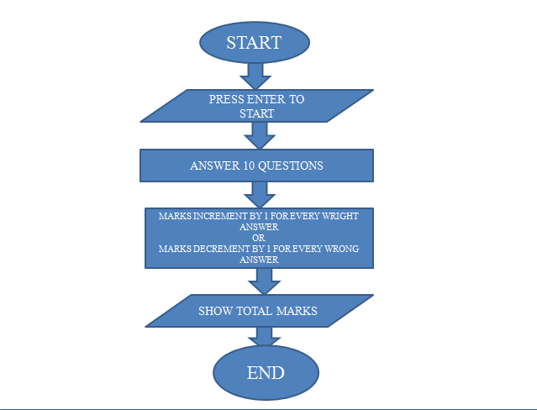

Figure 3.1: Simulation Procedure

## Results and Discussions

We have set 10 questions. For each right answer 1 mark will be increased and for each wrong answer 1 mark will be decreased from total points and at the end of the quiz total marks will be shown.

* + 1. **Results**

# Chapter 4 Conclusion

## Introduction

This is really an interesting quiz system. Anyone can judge himself within a short time by this quiz system. We also gather a huge knowledge about Assembly Language by completing this project. We also hope that in future we can make more project in Assembly Language.

## Practical Implications

* Online Quiz Exam
* Self-Quiz System

## Scope of Future Work

Our project will be able to implement in future after making some changes and modifications as we make our project at a very low level. We make it more user friendly. We add more question.

# References

1. <https://www.youtube.com/watch?v=D9HNXkyksZA&t=11s>

2. https://www.youtube.com/watch?v=WaTTfheZorY